Matt’s recommended analysis

1. Open Results.xlsx and add three additional columns (C,D,E)
   * Called “Geno”, “Leaf”, “Name”
2. We need to extract a unique Name for every image, gather together all the same Leaves, and gather together all the same Genotypes. I did this in a simple way, the script gives you:

Label = folder/image name.czi:info

Label = “NHLexp NHL Leaf(1).czi/NHLexp NHL Leaf(1) (2).czi:0001-0001-0011:z:1/16 - NHLexp NHL Leaf(1) (2).czi #1”

* To get
  + Geno: =LEFT(B2,10) “NHLexp NHL”
  + Leaf: =LEFT(B2,FIND("/",B2)-1) “NHLexp NHL Leaf(1).czi”
  + Name: =LEFT(B2,FIND(".czi",B2,25)-1) “NHLexp NHL Leaf(1).czi/NHLexp NHL Leaf(1) (2)”

Label = “cml41-01/cml41-1 Leaf2 (2).czi:0001-0001-0138:z:1/22 - cml41-1 Leaf2 (2).czi #1”

* To get
  + Geno: =LEFT(B2,FIND("-",B2)-1) “cml41”
  + Leaf: =LEFT(B2,FIND("/",B2)-1) “cml41-01”
  + Name =LEFT(B2,FIND(".czi",B2)-1) “cml41-01/cml41-1 Leaf2 (2)”

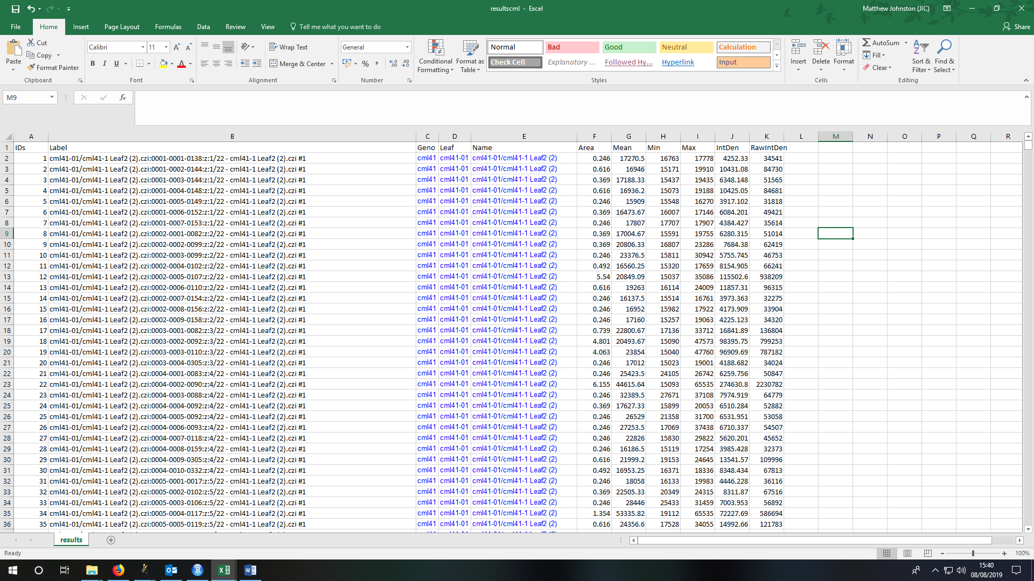

1. In R, open “CalloseAnalysis.R”
2. Copy all of the data from Geno to RawIntDen (CTRL+C)
3. Then click “Run”
   * Your results will come out in BoxPlot form.

